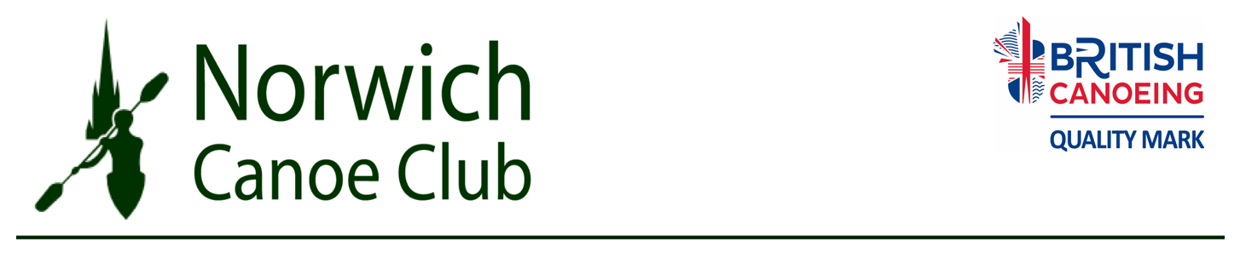
MEMBERSHIP FORM 2018. Please fill in a separate form for each member.

Name:

Address:

Post Code:

Telephone No: Mobile No:

Email (to receive club updates) :

Date of birth Age on 1st Jan 2018

Occupation(optional) School/College/University
BCU membership No (if applicable)

Type of membership (please tick)
Senior  Over 18  £225  (£18.75 a month) | Under 18  £192  (£16 a month) | Over 18 in full time education  £192  (£16 a month) | Family  (maximum of 2 carers  and 1 or more children)  £588  (£49 a month) | Social Membership  £45  (£3.75 a month)

I have paid the full amount electronically- please give date and reference used
I enclose a cheque (do not enclose cash)
I have an existing standing order or will set one up within the month.

Account: Lloyds Bank, Norwich Canoe Club, Sort code: 30-96-17 Acc number : 04603805
Please use your name in the reference so we can track payments accurately.
Please give the forms to Lucinda Osbourne (membership secretary)
Membership includes coaching, racking for one K1, one K2 and the authorised use of Club equipment and boats.
Bursaries are available, please see website for details.

Confidential Medical Details.

Name D.O.B

All information is confidential and will only be used, as appropriate, during club activities
First Emergency Contact Name & Tel

Emergency contact’s relationship to Paddler

Second Emergency Contact Name & Tel

Emergency contact’s relationship to Paddler

Doctor’s name and Surgery

Doctor’s Tel No:

Please answer the questions below to help us make paddling safe for all.

A ‘YES’ answer won’t necessarily place a restriction on your activities within the club.
 | Yes | No | If you have answered yes please give details including relevant medication.
Do you suffer from any health problems that are aggravated by exercise or exposure to the cold?
Do you suffer from asthma?
Do you suffer from diabetes?
Do you suffer from epilepsy?
Do you have a heart condition?
Do you suffer from any persistent injury including problems with your joints or back?
Do you suffer from hearing or sight impairment?
(excluding normal use of spectacles)
Do you consider yourself to have a disability? For a junior paddler please give full details of any special needs and also supervision requirements that we may need to consider.
Do you have any allergies?
Any other health issues that coaches should be aware of for safety reasons

IMPORTANT Please inform the coach or lead paddler of your group if you are carrying medication i.e. inhalers, insulin etc. so that coaches aware of potential problems and can provide suitable assistance if required.

CONSENT FOR PERSON OVER 18 AND NOT IN ANOTHER’S CARE.

- I am physically able to take part in the activities of Norwich Canoe Club, whether at the location of the Club or at an event away from the club.
- I will abide by the Club Rules, Operating Procedures & Policies, which are available on the Club Website and Notice Board. Copies are available on request.
- I can swim 50m in the clothing that I wear for canoeing.
- The information I have given is true.
- I do give/do not give permission to be included in any Photo/Video Programme/Press Release, Information, Web Site, that the Club may use for training, administration, applying for funding and publicity purposes.

Signature……………………………………………

CONSENT FROM PARENTS AND CARERS FOR PERSON UNDER 18 OR OVER 18 BUT IN ANOTHER’S CARE

- My child/the child or person in my care is physically able to take part in the activities of Norwich Canoe Club, whether at the location of the Club or at an event away from the club.
- My child/the child or person in my care will abide by the Club Rules, Operating Procedures & Policies, which are available on the Club Website and Notice Board. Copies are available on request.
- My child/the child or person in my care can swim 50m in the clothing that they will wear for canoeing.
- The information I have given is true.
- I do give/do not give permission for my child/the child or person in my care to be included in any Photo/Video Programme/Press Release, Information, Web Site that the Club may use for training, administration, applying for funding and publicity purposes in accordance with The British Canoe Union Guidelines For Use Of Photographic & Filming Equipment

Signature………………………………………. Name…………………………………………………..

The club relies on volunteers to help with various activities including the Saturday kitchen rota, paddle-ability sessions or helping at social events. This is how we keep our costs down. Please contact out volunteer coordinator to organise helping out on very occasional saturday kitchen rotas. Its a great way to meet everyone! catering@norwichcanoeclub.co.uk

Norwich Canoe Club Data Protection Policy.
The Norwich Canoe Club Data Protection Policy ensures that the information you supply is treated fairly and lawfully in accordance with the Data Protection Act 1998. The information you supply is used for the efficient and lawful administration of the Club. From time to time however the Club is asked to supply certain information to Sporting bodies such as the British Canoe Union and also to Insurers and Grant Providers.

A copy of the Canoe Club Data Protection Policy is available on the Club Website and Notice Boards and a hard copy is available on request.

Legal Note.
To the extent permitted by applicable laws, Norwich Canoe Club accept no liability for any direct, indirect, incidental, special or consequential loss or damage to anybody (whether arising in contract, tort including negligence or otherwise) arising out of or in connection with any of its activities except for personal injury or death of any person caused by negligence.

