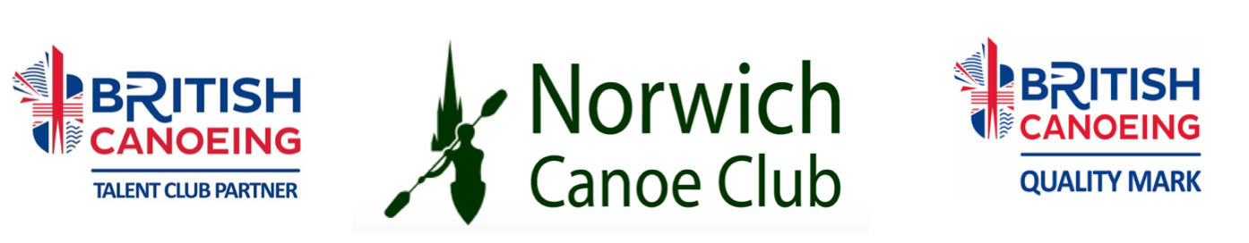
MEMBERSHIP FORM 2019. Please fill in a separate form for each member.

Name:
Telephone No: | Mobile No:
Email (to receive club updates) :
Date of birth: | Age on 1st Jan 2019:
Occupation(optional)
If Student your School/College/University
BCU membership No (if applicable)

Type of membership (please tick)
Senior  Over 18  £225  (£18.75 a month) | Under 18  £192  (£16 a month) | Over 18 in full time education  £192  (£16 a month) | Family  (maximum of 2 carers  and 1 or more children)  £588  (£49 a month) | Social Membership  £45  (£3.75 a month)
Please tick payment details
I have paid the full amount electronically. Please give the date this was done.
Please use your name and MEM in the reference
I enclose a cheque (do not enclose cash)
I have an existing standing order or will set one up within the month.
Please use your name and MEM in the reference

Account: Lloyds Bank, Norwich Canoe Club, Sort code: 30-96-17 Acc number : 04603805
Please use your name in the reference so we can track payments accurately.
Please give the forms to our membership secretary or one of the membership team.

Membership includes coaching, racking for one K1, one K2 and the authorised use of Club equipment and boats.
Bursaries are available, please see website for details.

Confidential Medical Details.
Name: D.O.B:
All information is confidential and will only be used, as appropriate, during club activities
First Emergency Contact Name & Tel:
Emergency contact’s relationship to Paddler:
Second Emergency Contact Name & Tel:
Emergency contact’s relationship to Paddler:
Doctor’s name and Surgery:
Doctor’s Tel No:
Please answer the questions below to help us make paddling safe for all. We rely on your explicit consent to collect and process information.
A ‘YES’ answer won’t necessarily place a restriction on your activities within the club.

 | Yes | No | Please give details including  relevant medication.
Do you suffer from any health problems that are aggravated by exercise or exposure to the cold?
Do you suffer from asthma?
Do you suffer from diabetes?
Do you suffer from epilepsy?
Do you have a heart condition?
Do you suffer from any persistent injury
including problems with your joints or back?
Do you suffer from hearing or sight impairment?(excluding normal use of spectacles)
Do you consider yourself to have a disability? For a junior paddler please give full details of any special needs and also supervision requirements that we may need to consider.
Do you have any allergies?
Any other health issues that coaches should be aware of for safety reasons

IMPORTANT Please inform the coach or lead paddler of your group if you are carrying medication i.e. inhalers, insulin etc or there are any other health issues that could affect your health and safety during a club session. Coaches need to be aware of potential problems and can provide suitable assistance if required.

CONSENT FOR PERSON OVER 12

- I am physically able to take part in the activities of Norwich Canoe Club, whether at the location of the Club or at an event away from the club.
- I will abide by the Club Rules, Operating Procedures & Policies, which are available on the Club Website and Notice Board. Copies are available on request.
- I can swim 50m in the clothing that I wear for canoeing.
- The information I have given is true.
Please tick one option
I give my permission to be included in any photo or video containing my image to be included in any photo, video programme, press release, programme/, press release, information, web Site, or social media that the Club may use for training, administration, applying for funding and
publicity purposes. I understand I can withdraw my consent at any time.
I do not give my permission for any photo or video or video containing my image to be used for any purpose.

Signature……………………………………………

CONSENT FROM PARENTS AND CARERS FOR PERSON UNDER 12 OR OVER 12
BUT IN ANOTHER’S CARE

- My child/the child or person in my care is physically able to take part in the activities of Norwich Canoe Club, whether at the location of the Club or at an event away from the club.
- My child/the child or person in my care will abide by the Club Rules, Operating Procedures & Policies, which are available on the Club Website and Notice Board. Copies are available on request.
- My child/the child or person in my care can swim 50m in the clothing that they will wear for canoeing.
- The information I have given is true.
Please tick one option
I give my permission for my child to be included in any photo or video containing my image to be included in any photo, video programme, press release, programme/, press release, information, web Site, or social media that the Club may use for training, administration, applying for funding and publicity purposes. I understand I can withdraw my consent at any time.

I do not give my permission for any photo or video or video containing my child’s image to be used for any purpose.

Signature……………………………………………

Volunteering
The club relies on volunteers to help with various activities including the Saturday kitchen rota, paddle-ability sessions or helping at social events. This is how we keep our costs down.
Everyone is expected to help. Your membership fees cover only a half of the costs of running the club. Please contact out volunteer coordinator to organise helping out on very occasional saturday kitchen rotas. Its a great way to meet everyone! catering@norwichcanoeclub.co.uk

Norwich Canoe Club Data Protection Policy.
The Norwich Canoe Club Data Protection Policy ensures that the information you supply is treated fairly and lawfully in accordance with data protection legislation. Please read the Canoe Club Data
protection policy on our website.

